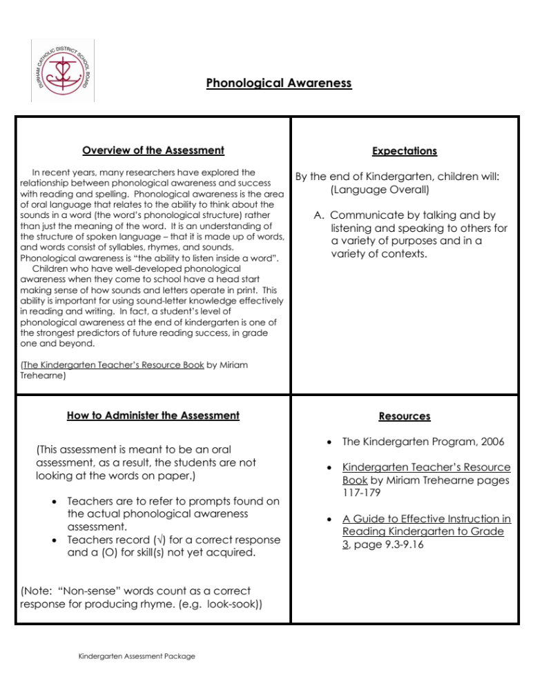

Phonological Awareness Assessment

Student Name: ______________________________________

Date: ____________________

Record a “✓” for a correct response and a “O” for an error.

Recognize Rhyme (Teacher: Rhyming words sound the same at the end. Tell me if these words rhyme or not. “cat – bat” [Y])
book – look (Y) |  | soap – sun (N) |  | supper – carpet (N) |  | shower – tower (Y)

Produce Rhyme (Teacher: I’ll say a word and then you say a word that rhymes with it. Let’s try one: Teacher says cat…) Record the words the child generates.
bug - | hook - | pot - | sun -

Segment Sentences (Teacher: Show me how many words are in this sentence. You can clap, count, move blocks, etc. to show how many words there are. Listen carefully… She reads the book. [4]
Lions roar. [2] |  | He eats cookies. [3]
My friend plays soccer. [4] |  | They are happy. [3]

Segment Syllables (Teacher: Show me how many parts there are in this word. You can clap, count, move blocks, etc. to show how many parts there are in the word. Listen carefully: cowboy [2]
Monday [2] |  | coat [1] |  | today [2] |  | dinosaur [3]

Blend Syllables (Teacher: Blend the two parts and tell me the whole word. Listen carefully… pen-cil)
base - ball |  | sleep - ing |  | win - dow |  | com-pu-ter

Beginning Sounds (Teacher: Tell me the beginning sound in the word “phone”. /f/
bike |  | Sat |  | moon |  | fun

Notes and Observations:

Phonological Awareness Assessment Summary Sheet

Student Names | Recognize Rhyme ( /4) | Produce  Rhyme ( /4) | Segment Sentences ( /4) | Segment Syllables ( /4) | Blend  Syllables ( /4) | Beginning Sounds ( /4)

