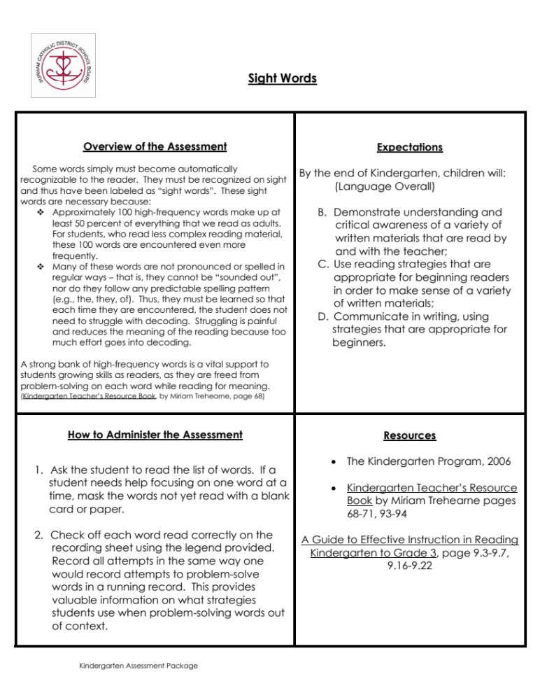

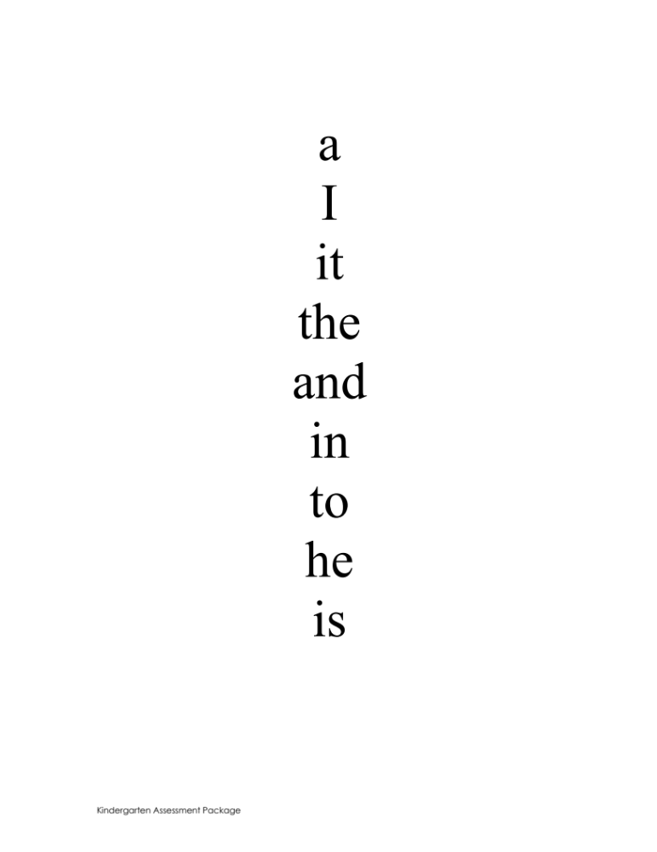

Sight Words Class Recording Sheet

Teacher Name: ______________________

Name | Identify  Name | a | I | it | the | and | in | to | he | is

