Nenaabgaanh Bkwezhigaansag

1 naagan zaawaamide (Butter)
1/4 naagan zaawaa-ziisbakwad (brown sugar)
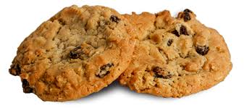
1/4 naagan waabi-ziisbaakwad (white sugar)
1 waawan (egg)
1 emkwaanens vanilla
1 1/2 naaganan naapaane (Flour)
1 emkwaanens baking soda
1/2 emkwaanens ziitaagan (salt)
1 emkwaanens cinnamon
1/4 emkwaanens nutmeg
2 1/2 – 3 naaganan nenaabgaanh (oatmeal)
1 naagan zhoominag (raisins)

Stir zaawaamide miinwaa ziisbakwad until fluffy. Beat in waawan miinwaa vanilla. Add in naapaane, baking soda, ziitaagan miinwaa spices. Stir in nenaabgaanh miinwaa zhoominag.

Drop by emkwaan onto ungreased bkwezhigaans tray. Bake for 8-9 minutes at 375.

Let cool then Wiisinidaa!

