COVID-19 Screening

The Ministry of Education has instructed Ontario School Boards to complete active screening for all students, staff and visitors to our schools for the first 10 days of school following Christmas break from January 3 to 14, 2022.
All students and staff are required to conduct daily screening for symptoms of COVID-19 before attending school using the COVID-19 school screening tool. You can access the COVID-19 school screening tool with the QR Code provided below. Please do not send your child(ren) to school if they have symptoms or have not passed the COVID-19 self-assessment.
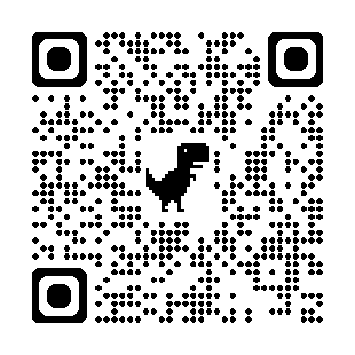

Parent/Guardian Sign Off
If you child receives a green check mark and passes the screening, then please initial under each date and send this piece of paper to school. Your child’s classroom educator will check for your signature daily from January 3 to 14, 2022.

JANUARY 2022

Monday | Tuesday | Wednesday | Thursday | Friday
3 | 4 | 5 | 6 | 7
10 | 11 | 12 | 13 | 14
17 | 18 | 19 | 20 | 21
24 | 25 | 26 | 27 | 28
31

